**Lab Exercise 3- Working with Git Rebase**

**Lab Exercise: Git Rebase**

This exercise demonstrates the use of git rebase in a scenario where no conflicts occur.

**Objective**

1. Learn how to rebase branches when there are no conflicting changes.
2. Understand the clean, linear history created by git rebase.

**Prerequisites**

1. Install Git on your system.
2. Initialize a Git repository:

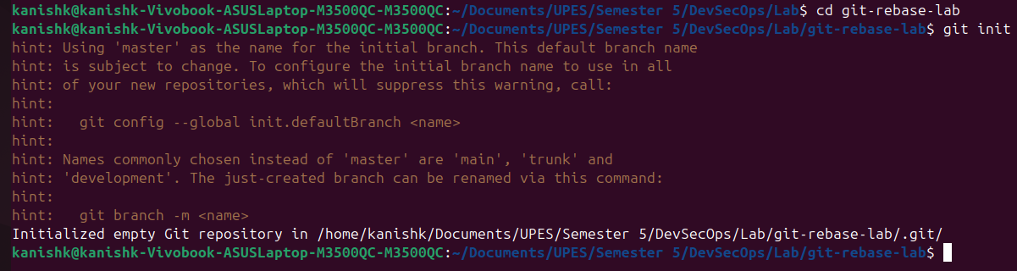**Step-by-Step Instructions**

**1. Set Up the Repository**

1. Create the main branch and make the initial commit:



1. Create a new branch feature-branch:



1. Add a new line to file.txt in feature-branch:



1. Switch back to the main branch and add another line:

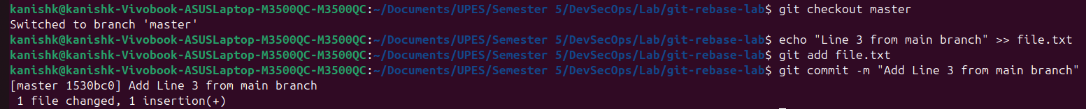

**2. Rebase feature-branch onto main**

1. Switch to feature-branch:



1. Rebase feature-branch onto main:



1. Git will replay the commit from feature-branch onto the main branch. Since there are no conflicts, the rebase completes automatically.

**3. Verify the Rebase**

1. View the commit history:

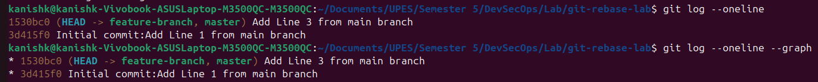

1. Check the contents of file.txt:

